**Lesson 9 Demo 2**

**Configuring Webhook trigger for Jenkins’s job**

**Objective:** Configure a Freestyle Jenkins job implement webhook build trigger in Jenkins.

**Tools required:** Jenkins

**Pre-requisites:** You need to have a Jenkins up and running.

Steps to be followed:

1. Log in to Jenkins CI tool and configure freestyle job to trigger build using webhook trigger.

**Step 1: Log in to Jenkins CI tool and configure freestyle job to trigger build using webhook trigger.**

1. Login to Jenkins CI tool with admin user and click on New Item to create new Jenkins’s job.

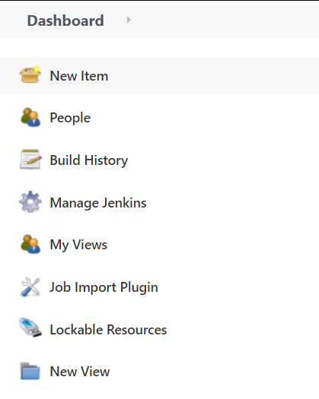

1. Select Freestyle project while creating Jenkins’s job and provide custom job name.

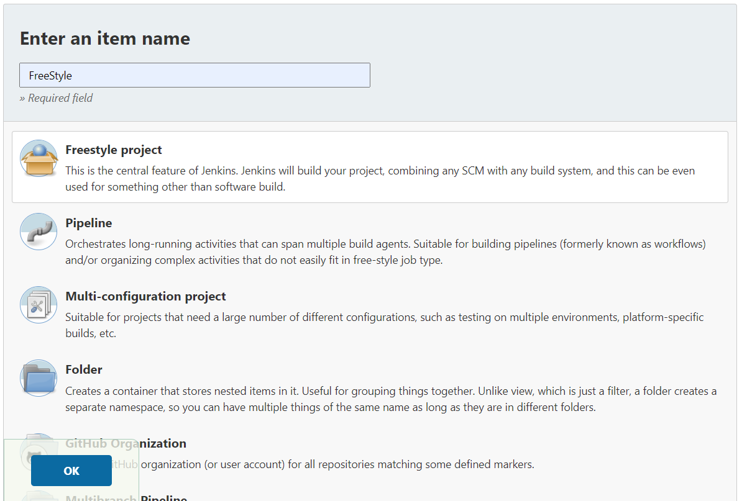

1. Once job name is provided, click on Ok button to save Jenkins’s job and a new configuration screen would be opened.

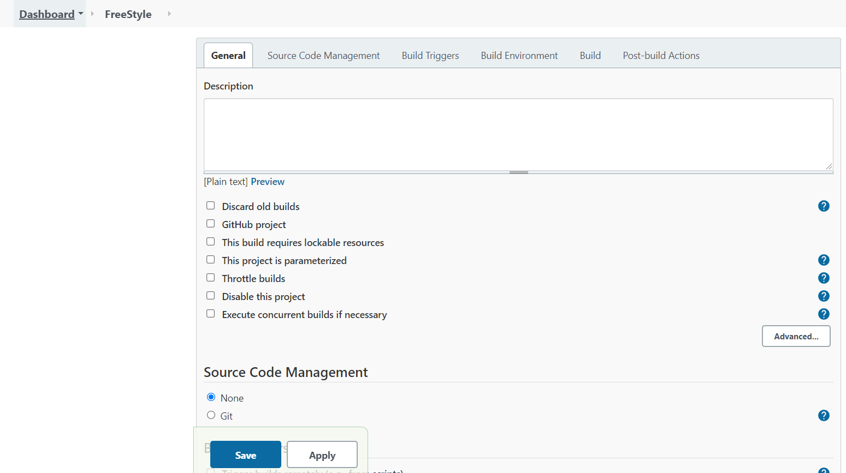

1. In configure screen you need to access Source Code Management tab to provide Git repository configurations.

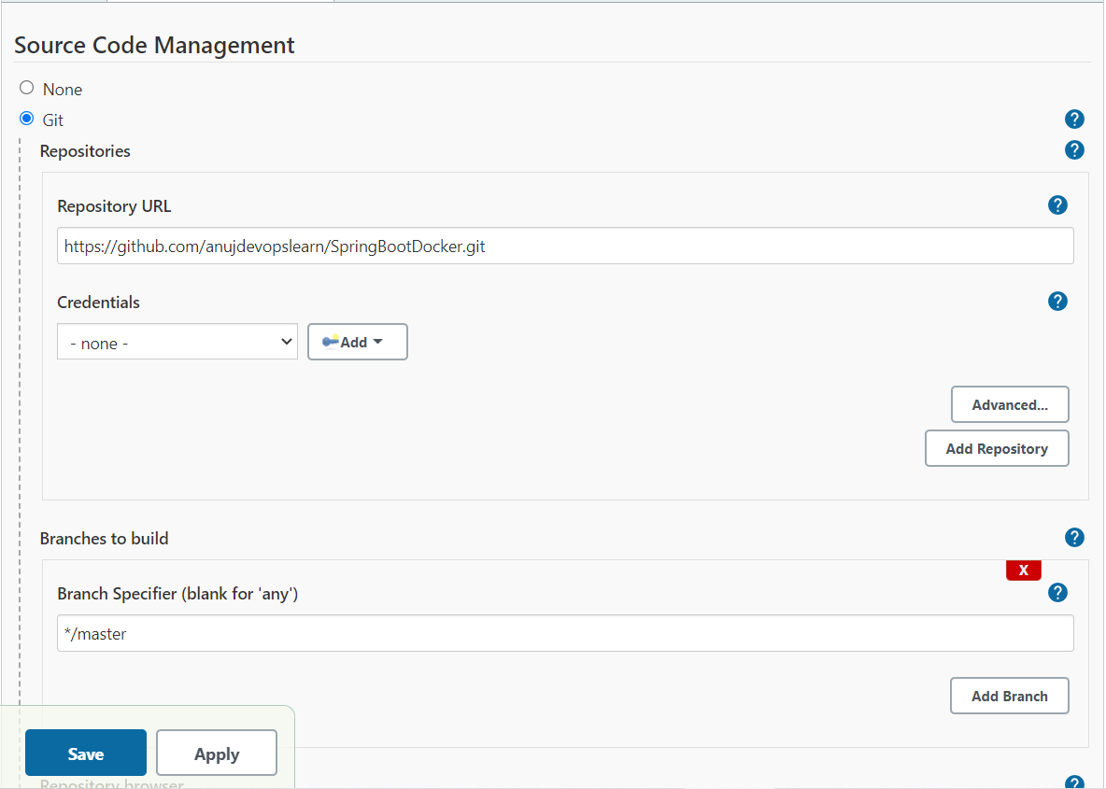

1. Once Git repositories configurations are configured in Jenkins’s job, you can configure webhook Build Triggers so that you don’t have to trigger Jenkins’s job manually.

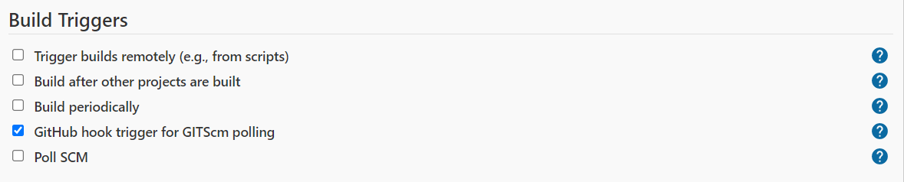

1.6 Next you need to login to GitHub repository so that you can configure webhook trigger at GitHub end also.

1.7 Next you need to generate token, which can be easily created by editing your profile and navigate to API Token section.

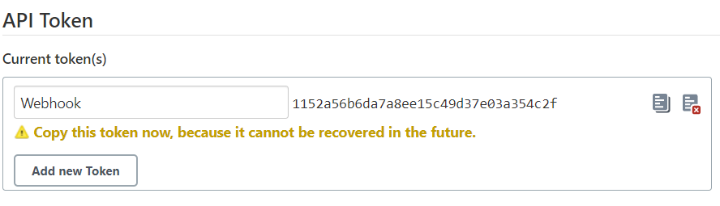

Preserve this token, since once this token is generated, you would not be able to re-generate it again.

1.8 Access Settings tab in GitHub for specific Git repository configure above and then select webhooks option:

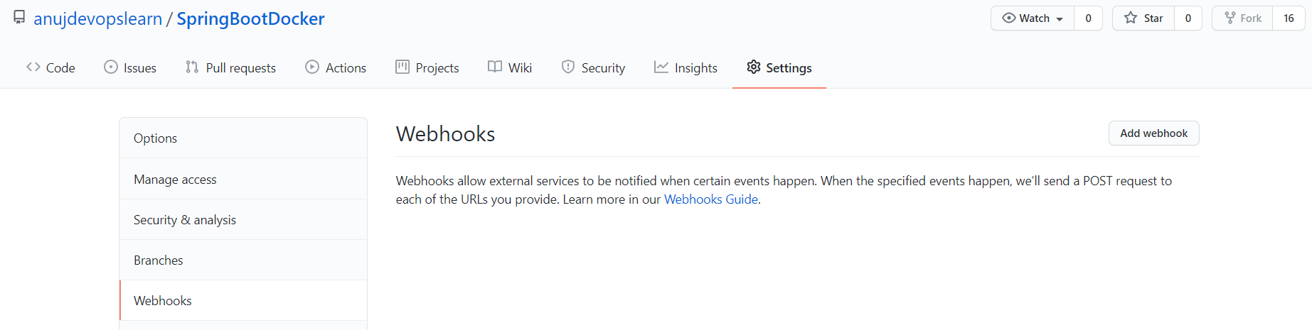

1.9 Then click on Add Webhook and provide below details:

**Payload URL: http://<JENKINS-HOST>:8080/github-webhook/**

**Secret: Secret Generated in Jenkins as per 1.7 Step.**

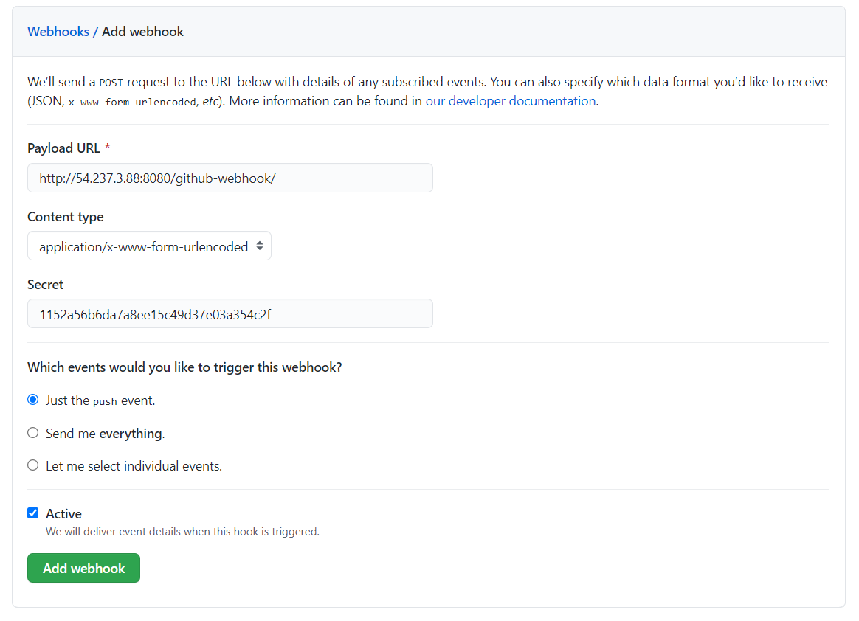

1.10 Post all these configurations, all you need to do is to commit a new change in Git repository and Jenkins’s build would be triggered automatically without any delay and without any human interference.